For immediate release

DaDaFest: Creating Art, Challenging Attitudes, Changing Lives
DaDaFest International 2020: Translations announced
Award-winning disability and D/deaf arts organisation DaDaFest announces international online festival this November.
DaDaFest International will take place from 27 November – 3 December 2020 showcasing brand new artwork. And for the first time, it’s digital, online and FREE.
As a result, DaDaFest will be encouraging donations and a new film has been made to showcase DaDaFest’s life changing work.
View the film here.
This year’s festival theme is Translations which continues a 12 year journey for the organisation using the prefix ’trans’, used for its Latin meaning, ‘through,’ with its implications of change and moving forward.
We began that journey in 2012 and the festivals since then have explored the ideas associated with:
· Transactions (2012)
· Transmutate (2014)
· Transfuse (2016)
· Transpire (2018)
· Translate (2020)

Internationally renowned artist Alexandrina Hemsley brings her new work, Maelstrom Under Glass, to launch the festival.
The programme is made up of new artworks across a range of artforms, and includes a lot of firsts for DaDaFest: we’ve commissioned a podcast series, a board game, and even a fitness video (albeit with a disability arts twist).

The theme of ‘Translations’ is approached in all kinds of ways – Amina Atiq explores what it means to be ‘Yemeni-Scouse’, Hana Madness and Alexis Maxwell’s animation reveals UK-Indonesian differences and commonalities… and elsewhere Dominic G will be sharing his manifesto for a fictional nation of weasels!
Other artists featured include Tammy Reynolds who will be examining dwarfism and control of public gaze, Deaf Explorer’s cross-artform collective, Ngozi Ugochukwa presenting an exhibition around body scars, and many many more.
The festival will include BSL interpreted, Audio Described, Captioned events, and there will be easy read versions available, all to improve access.
The full DaDaFest International programme will include artist talks,
live Q&As and more, still to be announced.
Find out more about DaDaFest www.dadafest.co.uk
Follow @DaDaFest on Twitter, Instagram and Facebook for the latest festival announcements.
For images: https://drive.google.com/drive/folders/1vo3IyWKQy7VHRKhgWK6-IZ2i2KUebEZn
For interview opportunities with Festival organisers or artists, contact info@dadafest.co.uk

Ends
Notes to Editors
DaDaFest is an innovative and cutting edge disability and D/deaf arts organisation based in Liverpool that was established in 1984.

Our vision is to inspire, develop and celebrate talent and excellence in disability and D/deaf arts,
DaDaFest has played a key role in the development of disability and D/deaf arts in the UK and internationally. In 2001 we created DaDaFest International (DDFI) – our festival - to provide a much needed platform for disabled artists.
This will be our 15th successful International Festival.
Find out more about our work by visiting www.dadafest.co.uk
DaDaFest International
Funded by:
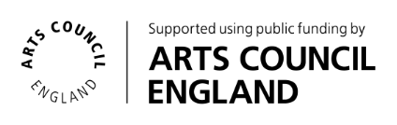

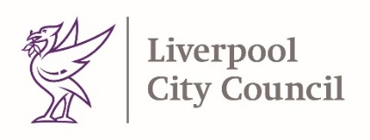
Funded by:

